**Project Description:**

ListMate, developed by Team R.U.S.T. (Resourceful Users Streamlining Tasks), is an innovative application designed to revolutionize grocery shopping and household management experience. ListMate addresses the common challenges of disorganized shopping and household inefficiencies by providing a comprehensive solution that enhances every aspect of the shopping journey. ListMate aims to assist users in managing their grocery shopping and household tasks with ease. The app helps users discover recipes, explore special offers, and collaboratively plan their shopping lists. This functionality ensures a more organized and harmonious household dynamic. The intended users for ListMate are individuals and families looking to streamline their household routines, from busy professionals to families juggling multiple schedules and preferences.

**Requirements Summary:**

Table 1. System Requirements To cater to low-end android models, the application will have at most a minimum of 1 Core, 2 GB worth or RAM, and Android version 4.4 or KitKat as its OS. The app itself is not at all demanding, hence our team has settled on lower requirement specs.

**Overview**

Due to the ongoing quarantine and online classes, the team is unable to conduct this evaluation through normal means. Instead, alternatives were used such as the use of online social media platforms like Microsoft Teams and Discord. This ensures that the team will still be able to see a live feed of what is currently happening in the prototype.

With that said, the evaluation plan is split into three separate parts: Usability Specifications, Heuristics Evaluation, and Participant Survey and Feedback. Below is a table describing each technique.

|  |  |
| --- | --- |
| **Technique** | **Description** |
| **Usability Specifications** | Usability Specifications is the technique used to evaluate the level of usability that the prototype has. It consists of tasks that will be done by participants. Furthermore, the technique will include timing the speed of participants at a given task. The tasks will be split into 3 sections: Main Menu Tasks, List Management Tasks, and Recipe Tasks. This task is chosen to properly identify what flaws are seen when the user interacts with the prototype and how easy it is to use the prototype. |
| **Heuristics Evaluation** | Heuristics Evaluation will evaluate the UX design of the prototype based on industrial-standard usability principles. This technique is chosen to provide a quick and approachable way to assess the validity of the prototype’s design when time or resources are limited. |
| **Participant Survey and Feedback** | A survey will be provided to participants after conducting the prototype. The survey will contain quantitative questions that are interpreted into a 5-point Likert Scale as well as qualitative questions in the form of feedback. This will ensure that no designer bias affects the results of this evaluation. |

**Prototype Tasks**

The tasks for this prototype are split into three (3) different sections: Main Menu Tasks, List Management Tasks, and Recipe Tasks. Below are some of the tasks that the selected participants will be asked to perform for each section to showcase the prototype’s functionality:

**Main Menu Tasks**

* **Enter and Exit the Prototype**: Participants will be asked to start and close the ListMate app to assess the ease of accessing the application.
* **Navigate the Main Menu**: Participants will explore the main menu to evaluate how intuitive and user-friendly the navigation is.

**List Management Tasks**

* **Create Shopping Lists**: Participants will be tasked with creating new shopping lists to assess the ease of initiating list creation.
* **Add Items to Shopping Lists**: Participants will add items to their shopping lists, evaluating the process's simplicity and efficiency.
* **Delete Items from Shopping Lists**: Participants will remove items from their shopping lists to ensure that the deletion process is straightforward and error-free.
* **Share Shopping Lists with Others**: Participants will share their shopping lists with another user to evaluate the collaboration features.

**Recipe Tasks**

* **Search for Recipes**: Participants will search for recipes within the app to assess the effectiveness of the search functionality.
* **Add Ingredients from Recipes to Shopping Lists**: Participants will add ingredients from a selected recipe directly to their shopping lists, evaluating the integration between recipes and lists.
* **Save Favorite Recipes**: Participants will save recipes to their favorites to assess how easily they can bookmark and retrieve preferred recipes.

**Rationale**

These tasks were selected for participants because the prototype was designed with these measures in mind:

* **Easy Navigation**: Ensuring users can easily find and use the features they need.
* **CRUD (Create, Read, Update, Delete)**: Allowing users to perform essential operations on shopping lists and recipes to manage their household shopping efficiently.

Method of conducting Online Tests:

Social media platforms were used in conducting the online tests for this evaluation. Below are screenshots showing how the evaluation underwent.

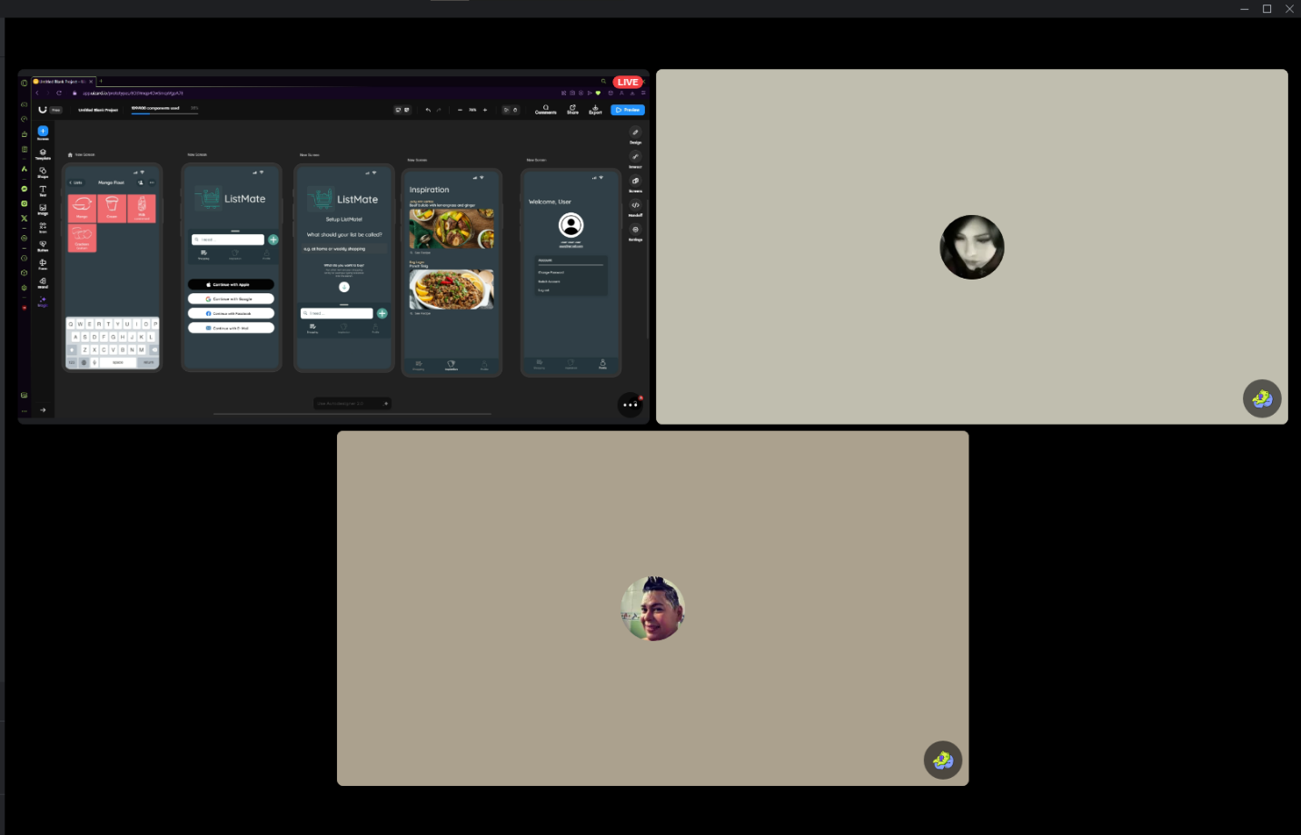

**Discord Call**

# Data Presentation

**Data Analysis**

## Usability Specifications

During the online testing with the Participants, the team noticed that the participants during this test have been interacting rather well with the prototype. Almost all the Participants were able to finish each task handed to them by the Members of the Team and were accomplished with little to no issues. Upon further observation, the participants were able to learn and memorize the steps and navigation of the Prototype. They were able to easily navigate their way through the prototype.

|  |  |  |  |
| --- | --- | --- | --- |
| Task | Mean | Interpretation | Classification |
| Main Menu Tasks | 1 minutes | Highly Acceptable | Successful |
| List Management Tasks | 2 minutes and 14 seconds | Highly Acceptable | Successful |
| Recipe Tasks | 1 minutes | Highly Acceptable | Successful |

Table 3. Task Time

Table 3 shows the results of the timed tasks during the Online Testing. The data shows that the Participants were overall able to accomplish each task sections with amazing times. With this result, the prototype is interpreted as successful in all three (3) task sections.

## Heuristic Evaluation

The ListMate prototype will be evaluated within each type of Heuristic Evaluation.

*Visibility of System Status*

The prototype was able to inform the participants what was going on within the Prototype.

*Match Between System and Real World*

The prototype uses basic English which can easily be understood by all ages within our participants. Words and Phrases easily understood by the Participants.

*User control and Freedom*

The prototype possesses fail-safes such as “Cancel” and “X” whenever participants were mis-clicking or did not understand the instructions clearly. Back Buttons were also implemented as another form of Fail-safe.

*Consistency and Standards*

Consistency was followed with a bit of issues here and there. Issues such as inconsistency with the position of the Back buttons and location of where to tap.

*Error Prevention*

Error prevention was followed to some degree with a few mishaps in the prototype. Such errors were minor but still affected the participant’s experience to some degree.

*Recognition rather than recall*

Options, objects, and actions were visible for the user to use during the Prototype.

*Flexibility and Efficiency of Use*

The prototype was easily understood and used proficiently by both the experienced and inexperienced of the FIGMA style prototype.

*Aesthetic and Minimalist Design*

The Prototype has a slick and simple that connects to the previous plan of Modern- Minimalistic feel. Furthermore, information that are of no necessities were not shown within the prototype.

*Help Users Recognize, Diagnose, and Recover from Errors*

Unfortunately, the prototype suffers from this Evaluation type. While the Prototype does indicate the user when they have clicked a part that has no interaction, the prototype was still unable to Help users with Plain Language, only indicators.

*Help and Documentation*

Users were able to access Help or Assistance through the form of the present team members.

*Heuristics Conclusion*

Overall, the Prototype was able to follow most of the Evaluations with some issues that still need to be properly addressed or fixed.

### **Participant Survey and Feedback**

#### **Results**

|  |
| --- |
| ****SECTION 1**** |
| |  |  |  |  | | --- | --- | --- | --- | | Question | Mean | Interpretation | Classification | | How would you evaluate your experience with the ListMate Prototype? | 5 | Acceptable | Successful | | How would you rate the UI design of the prototype? | 4.51 | Acceptable | Successful | | How easily were you able to follow the provided tasks? | 4.12 | Acceptable | Successful |   ****SECTION 2**** |
| | **Feature** | **Mean** | **Interpretation** | **Classification** | | --- | --- | --- | --- | | User-Friendly Interface | 4.32 | Acceptable | Successful | | Shopping List Management | 4.46 | Acceptable | Successful | | Recipe Integration | 3.93 | Moderately Acceptable | Neutral | | Smart Suggestions from Inspiration Tabs | 4.85 | Highly Acceptable | Successful | | Organizational Tools | 4.65 | Highly Acceptable | Successful | | Profile Accessibility | 4.65 | Highly Acceptable | Successful | | Average | 4.34 | Acceptable | Successful | |

**Table 3. Survey Data Interpretation**

The table represents the data for the survey conducted after the online testing. It shows that the prototype is at an Acceptable stage of quality and is deemed Successful. The team would still, however, like to focus on the Recipe Integration feature, which seems to have a Neutral consensus. Using the 10 Usability Heuristics Criteria, this data shows that the prototype was able to please the participants and follow the criteria with key points such as its Minimalistic Approach and Visibility.

#### Feedback

While most of the feedback was overwhelmingly positive, some focused on a few issues. Common issues revolved around the Recipe Integration feature of the prototype. These issues tend to raise concern that the integration was somewhat difficult to follow.

### **Critique and Summary**

#### **Advantages and Disadvantages of the Evaluation**

**Advantages:**

* The team successfully gathered crucial information and data essential for the ListMate prototype.
* It was easier to contact participants for the online test evaluation via social media platforms like Discord, facilitating the distribution of necessary links and instructions.
* The use of online tools allowed for a broad and flexible participant base, contributing to the robustness of the data collected.

**Disadvantages:**

* Lack of physical contact and laboratory work limited the depth of data collection, potentially missing out on nuanced user behaviors and interactions.
* Slower internet speeds affected the team's ability to assess the prototype efficiently, as delays in loading and interactions impeded real-time feedback and observation.

#### What Would You Have Done Differently?

**Design-wise and Evaluation-wise Adjustments:**

* **Separate Evaluations:** Conduct separate evaluations for the initial prototype and the revised version to gather more comprehensive data and insights at different development stages.
* **Enhanced Back-end Development:** With more resources, implement back-end coding to transition the prototype into a fully functioning application ready for submission to app stores.
* **Feature Expansion:** Improve the prototype by adding features such as Notifications and enhanced online capabilities, providing users with a richer experience and more functionality.

**Resource-Enhanced Evaluations:**

* **Additional Features:** Incorporate more advanced features like music integration and personalized suggestions to give the prototype a unique and modern feel.
* **Improved Testing Environments:** Utilize better testing environments, possibly with higher-speed internet connections and physical testing setups, to ensure smoother and more detailed evaluations.

#### **Summary of the Project**

The selected benchmark tasks were vital in assessing how well users could interact with the ListMate prototype. These tasks provided valuable insights into areas that needed improvement, especially concerning the CRUD system and navigation ease. While the prototype excelled in certain aspects, issues such as the renaming function and inconsistent navigation highlighted areas for enhancement. The team also faced limitations due to the lack of time, resulting in the exclusion of some planned online features. With more time, the prototype could have included these features, significantly enhancing user experience.

**Conclusions:**

* Designing an effective prototype requires substantial knowledge of interface design and a clear understanding of the target users and their needs.
* Despite the challenges, the participants' familiarity with Android UI, even as first-time users, indicated that the prototype was user-friendly.
* Overall, the ListMate prototype was deemed acceptable and effective, marking a successful design and evaluation process. The team gained valuable insights that would inform future iterations and improvements of the application.